# 

Detecting Parkinson’s Disease using Machine Learning

**Feasibility Report**

Team Members

### Gudipudi Vamsi Krishna (20481A5420) (Team Lead)

### Sonti Narasimha (20481A5451)

**Garisepalli Siva Ramanjaneyulu** **(21485A5403)**

**Keerthi Chawla**  **(20481A5430)**

**INDEX**

**CHAPTER 1: INTRODUCTION**  **3**

**1.1: Overview**  3

**1.2: Purpose**  4

**CHAPTER 2: LITERATURE REVIEW**  **5**

**2.1: Existing Problem** 5

**2.2: Proposed Solution** 5

**CHAPTER 3: THEORITICAL ANALYSIS**  **6**

**3.1Block Diagram** 6

**3.2Hardware/Software designing** 6

**CHAPTER 4:EXPERIMENTAL INVESTIGATIONS**  **7**

**CHAPTER 5: FLOWCHART**  **8**

**CHAPTER 6: RESULT**  **9**

**CHAPTER 7: ADVANTAGES& DISADVANTAGES**  **11**

**CHAPTER 8: APPLICATIONS**  **12**

**CHAPTER 9: CONCLUSION 13**

**CHAPTER 10: FUTURESCOPE**  **14**

**CHAPTER 11: BIBILOGRAPHY 15**

**APPENDEX**  **16**

**CHAPTER 1: INTRODUCTION**

### 

### 1.1 OVERVIEW?

Machine learning approaches for the early detection of Parkinson's disease typically involve using various algorithms and techniques to analyze data from different sources, such as voice recordings, gait analysis, medicalimaging, genetic data, and clinical assessments.

The goal is to develop accurate and reliable models that can distinguish between individuals with Parkinson's disease and healthy individuals at an early stage of the disease.

**Logistic Regression**: Logistic regression is a simple and interpretable model used for binary classification tasks.It can be employed to predict whethera patient is likely to have Parkinson's disease or not based ona set of featuresderived from various data modalities.

**Decision Tree Classifier**: A decision tree classifier is a popular and intuitive machinelearning algorithm used for classification tasks. It builds a tree-like model where each internal node represents a feature, each branch represents a decision basedon that feature,and each leaf node represents a class label (or class distribution) that the algorithm assigns to the input data.

**Random Forest**: Random Forest is an ensemble learning technique that combines multiple decision trees to make predictions. It can be used for both classification and regression tasks. RF can be employed to classify patients based on various features derived from medical imaging, geneticdata, or clinical assessments.

**K-Nearest Neighbors**: The k-Nearest Neighbors (KNN) classifier is a simple and popular machine learningalgorithm used for classification tasks.It belongs to the categoryof instance- basedlearning or lazy learning algorithms. Unlike model-based algorithms that learn a specific hypothesis during training, KNN doesn't explicitly learn a model. Instead, it memorizes the training data and makes predictions based on the similarity between the input data and the known data points in the training set.

## 

## 1.2 PURPOSE

The purpose of using a program in the context of early detection of Parkinson's disease is to develop a machine learning model that can effectively analyze various data sources, extract informative features, and accurately classify individuals as either having Parkinson's disease or being healthy. The ultimate goal is to achieve early and accurate detection of the disease, which can lead to timely intervention, improvedpatient outcomes, and better diseasemanagement.

Machine learning approaches offer several benefits and capabilities for early detection of Parkinson's disease:

**Improved Accuracy:** Machine learning models, such as Support Vector Machines, Random Forests, can process large and complex datasets, leading to better accuracy in detecting subtle patterns and disease markers.

**Feature Extraction:** Machine learning can automatically identify relevant features from different data modalities, such as voice recordings, gait analysis, brain imaging, and genetic data. These features can be used to build more informative and robust models.

**Multi-Modal Data Integration**: Machine learning enables the integration of diverse data sources, potentially improving the detectionaccuracy by leveraging complementary information from different modalities.

**Early Detection:** Machine learning models can identify early signs of Parkinson's disease before significant symptoms manifest, enabling early intervention and potentially slowing down disease progression.

**Risk Prediction:** Machine learning can be used to predict the risk of developing Parkinson's disease in at-risk populations based on demographic, genetic, and other relevant factors.

**Personalized Diagnosis:** Machine learning models can be tailored to individual patients, taking into account their unique characteristics and medical history, leading to personalized and more accurate diagnoses.

**Longitudinal Tracking:**Machine learning can analyze longitudinal data over time, helping to monitor diseaseprogression and evaluate the effectiveness of treatments.

**Reduced Cost and Time:** Automated machine learning models can process large datasets efficiently, potentially reducing the time and cost required for early detection compared to traditional diagnostic methods.

**CHAPTER2: LITERATURE REVIEW**

### 2.1 Existing Problem & Proposed Solution

To solve the machine learning problem of early detectionof Parkinson's disease,you can follow these general steps:

1. **Data Collection:** Gather relevant data from various sources, such as voice recordings, gait analysis, medical imaging, genetic data, and clinical assessments. The data should include samples from both individuals with Parkinson's diseaseand healthy individuals.
2. **Data Preprocessing:** Clean and preprocess the data to handle missing values, remove noise, and standardize the data if necessary. Data preprocessing is essential for preparing the data for training the machine learning models.
3. **Feature Extraction:** Extract informative features from the collected data. Depending on the data modality, you may need to use signal processing techniques for voice and gait data, image processing for medical imaging, and feature engineering for geneticand clinical data.
4. **Model Selection:** Choose appropriate machinelearning algorithms for the early detection task. Common classifiers include Support VectorMachines (SVM), RandomForests, Logistic Regression, and Deep Learning models (e.g., Convolutional Neural Networks or Recurrent Neural Networks).
5. **Model Training:**Train the selectedmachine learning modelsusing the trainingdataset and the extracted features. During training, the models will learn to identify patterns and relationships between the features and the target labels (Parkinson's disease or healthy).
6. **Model Evaluation:** Evaluate the trainedmodels using the testing datasetto assess theirperformance. Common evaluation metrics for classification tasks include accuracy, precision, recall, F1-score, and area under the receiver operating characteristic curve (AUC-ROC).
7. **Hyperparameter Tuning:** Optimize the hyperparameters of the machine learning models to improve their performance. This can be done using techniques like grid search or random search.
8. **Validation and Generalization:** Perform cross-validation to ensure that the model's performance is not overfitting to the training data and can generalize well to new, unseendata.
9. **Deployment and Integration:** Once a suitable model is trained and evaluated, deploy it in a real-world setting for early detection of Parkinson's disease. Integrate the model with the relevant healthcare systems or wearable devices, if applicable

**CHAPTER 3: THEORITICAL ANALYSIS**

## 3.1 Block Diagram

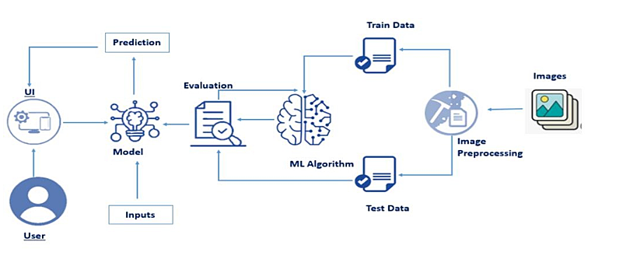

Fig:Block Diagram

**3.2 Hardware/Softwaredesigning**

**Hardware Components:**

**Central Processing Unit (CPU):** Most machine learning tasks involve heavy computational operations, and a powerful multi-core CPU is essential for data preprocessing, model training, and inference.

**Graphics Processing Unit (GPU):** GPUs are highly parallel processors that can accelerate training and inference tasks for deep learning models. They are particularly beneficial for computationally intensive tasks like neural network training.

**Memory (RAM):** Sufficient RAM is crucial for handling large datasets and complex models efficiently. A largerRAM capacityallowsforfaster data access and manipulation.

**Storage (SSD/HDD):** High-speed storage is necessary to handle large volumes of data. Solid State Drives (SSDs) are preferred for their faster read/write speeds compared to Hard Disk Drives (HDDs)

**Software Components:**

**Programming Language:**Python is the most widelyused programming languagefor machine learning due to its extensive libraries (e.g., NumPy, Pandas, Scikit-learn, TensorFlow, PyTorch) specifically designed for data manipulation and machine learning tasks.

**Data Visualization Tools:** Matplotlib and Seaborn are widely used Python libraries for creatingvisualizations to understand data patterns and model performance**Integrated Development Environment (IDE):** IDEs like Jupyter Notebook, PyCharm, or VSC odeprovide a user-friendly interface for coding, debugging, and experimentation.

**CHAPTER 4: EXPERIMENTAL INVESTIGATION**

There have been a number of investigations made while working on solutions using machinelearning approaches for early detectionof Parkinson's disease(PD). These investigations have explored a variety of data sources, including:

**Speech:** Voice changes are one of the earliest symptoms of PD. ML algorithms have been used to analyze voice recordings to identify features that are predictive of PD.

**Movement:** PD can cause a variety of movement abnormalities, such as tremors, rigidity, and slownessof movement. ML algorithms have been used to analyzemovement data, such as gait recordings, to identify features that arepredictive of PD.

**Imaging:** Imaging techniques, such as MRI and PET scans, can be used to visualize changes in the brain that are associated with PD. ML algorithms have been used to analyzeimaging data to identify features that are predictive of PD.

In addition to these data sources, researchers have also investigated the use of other datasources, such as:

**Gene expression:** Changes in gene expression can be a early markerof PD. ML algorithms have been used to analyze gene expression data to identify features that are predictive of PD.

**Metabolomics:** Metabolites are small molecules that are produced by the body. Changes in metabolite levels can be a early marker of PD. ML algorithms have been used to analyzemetabolomics data to identify features that are predictive of PD.

The results of these investigations have been promising. In some studies, ML algorithms havebeen able to achieve accuracies of up to 90% in distinguishing between patients with PD and healthy controls.

However, there are still some challenges that need to be addressed before ML can be widelyused for early detection of PD. These challenges include:

**Data availability:** Large datasets of labeled data are needed to train ML algorithms. However, these datasetscan be difficult and expensive to obtain.

**Data quality:** The quality of the data used to train ML algorithms can have a significant impact on the accuracy of the results.However, the qualityof data can be affectedby factors suchas the way the data is collected and the equipment used to collect it

Here are some of the most commonlyused ML algorithms for early detection of PD:

**Random forests:** Random forests are a type of ensemble learning algorithm that combinesmultiple decision treesto make predictions. Random forestshave been shownto be effective for early detection of PD, as they can improve the accuracy of predictions by reducing overfitting.

## CHAPTER 5: FLOWCHART

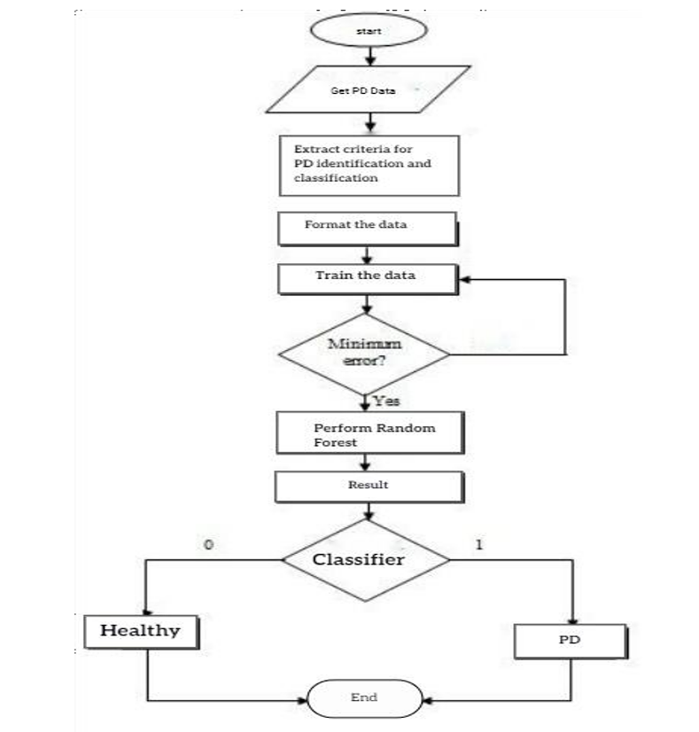

## CHAPTER6: RESULT

## Home page:

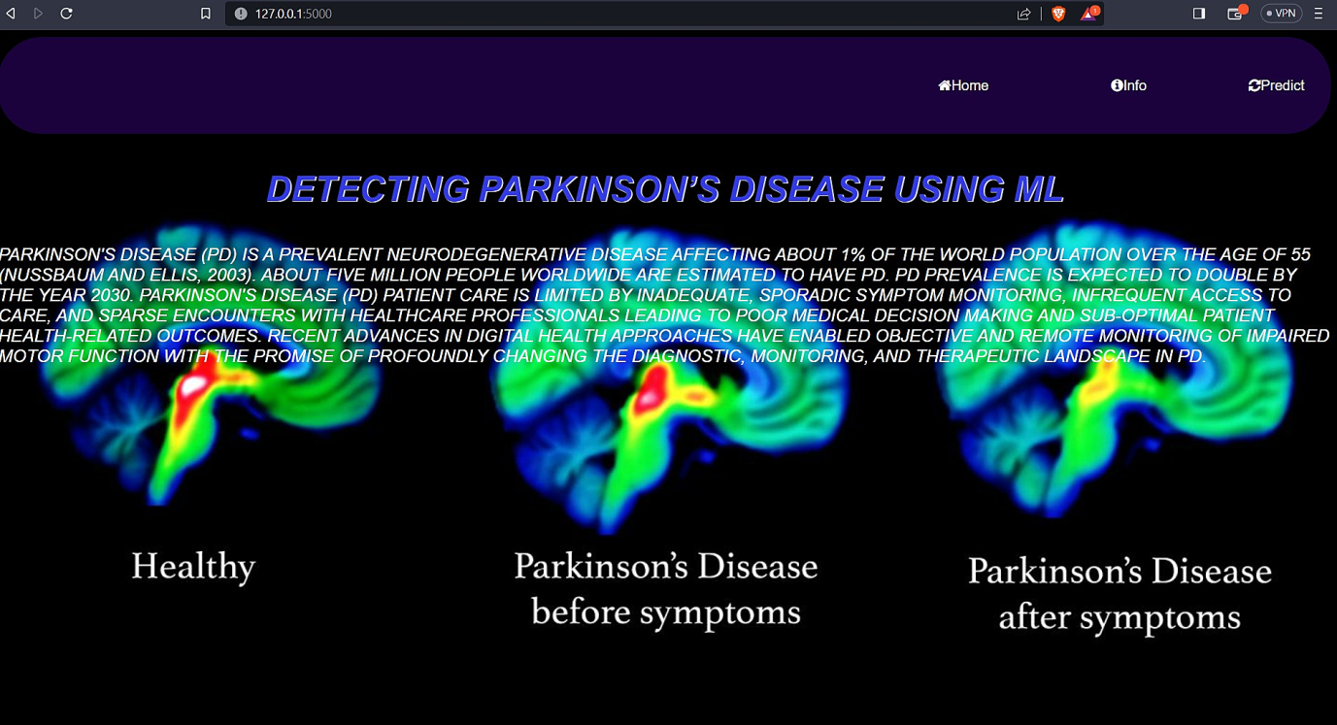

**Information page:**

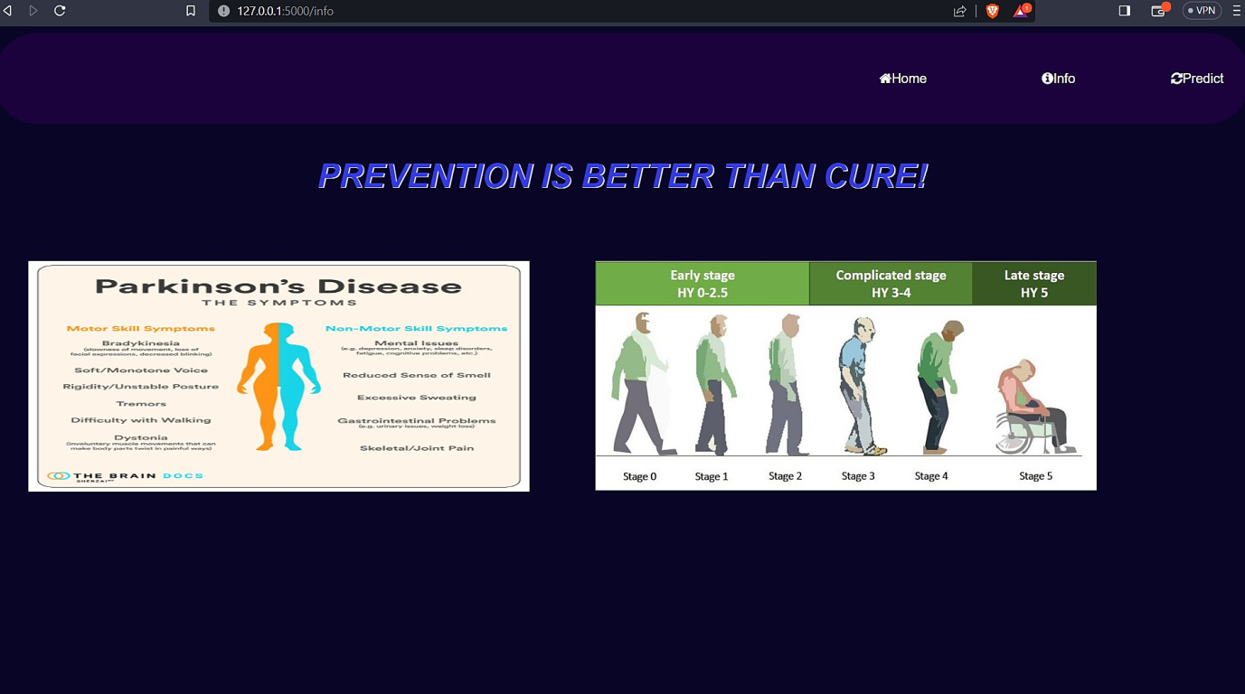

## 

## Prediction page:

step1:prediction the page



Step2: Upload the image and click the predict button



Step3:Reload the predict page show the prediction result

**CHAPTER7 : ADVANTAGES AND DISADVANTAGES**

### ADVANTAGES:

The advantages of machine learningapproaches for earlydetection of Parkinson's disease (PD):

* **Accuracy:** Machine learning algorithms can be trained to identify features in data that are predictive of PD. This can lead to more accurate diagnosis of PD, even in the early stages of the disease.
* **Scalability:** Machine learning algorithms can be scaled to large datasets of data. This makes it possible to use machine learning to analyze data from a large number of patients, which can improve the accuracy of diagnosis.
* **Cost-effectiveness:** Machine learning algorithms can be implemented using relatively simple and inexpensive hardware. This makes it possible to use machine learning to develop affordable methods for early detection of PD.
* **Non-invasive:** Machine learningalgorithms can be used to analyze data that is collected non-invasively. This means that patients do not have to undergoany invasive procedures, such as surgery or biopsies.

**DISADVANTAGES:**

The disadvantages of machine learning approaches for early detection of Parkinson's disease(PD):

* **Data availability:** Large datasets of labeled data are needed to train machine learning algorithms. However, these datasets can bedifficult and expensive to obtain.
* **Data quality:** The quality of the data used to train machine learning algorithms can have a significant impact on the accuracy of the results. However, the quality of data can be affected by factors such as the way the data is collected and the equipment usedto collect it.
* **Interpretability:** It is important to be able to understand how machine learningalgorithms make their predictions. This can be difficult, as ML algorithms are often complex and their decision-making processes are not always transparent.
* **Overfitting:** Machine learning algorithms can be prone to overfitting, which means that they may learn the training data toowell and not generalize well to new data.
* **Bias:** Machine learning algorithms can be biased, which means that be more likelyto misclassify certaingroups of people.This can be a problem if the data used to train the algorithm is not representative of the population of interest.

## CHAPTER8: APPLICATIONS

Machine learning approaches for early detectionof Parkinson's disease(PD) have the potential to be applied in a number of areas in the future. These areas include:

* **Personalized medicine:** Machine learning algorithms can be used to developpersonalized treatment plans for patients with PD. This can help to improve the effectiveness of treatment and improve the quality of life for patients.
* **Clinical trials:** Machine learning algorithms can be used to identify patients who are most likely to benefit from clinical trials. This can help to improve the efficiency of clinical trials and make them more likely tobe successful.
* **Public health:** Machine learning algorithms can be used to identifyat-risk populations for PD. This can help to raise awareness of the disease and improve early detection rates.
* **Research:** Machine learning algorithms can be used to identify new biomarkers for PD. This can help to improve the understanding of the disease and develop new treatments.

As the field of machine learning continues to develop, it is likely that new and innovative applications for machine learning approaches for early detection of PD will be developed. These applications have the potential to improve the lives of millions of people around the world.

## CHAPTER 9: CONCLUSION

## 

In conclusion, machine learning approaches for early detection of PD are a promising area of research.With continued development, these approaches have the potentialto revolutionize the way we diagnose and treat PD.

Here are some of the key findingson machine learningapproaches for early detection of PD:

* Machine learningalgorithms can be trained to identify featuresin data that are predictive of PD. This can lead to more accurate diagnosis of PD, even in the early stages of thedisease.
* Machine learning algorithms can be scaled to large datasets of data. This makes it possibleto use machine learning to analyze data from a large numberof patients, whichcan improve the accuracy of diagnosis.
* Machine learningalgorithms can be implemented using relatively simple and inexpensive hardware. This makes it possible to use machine learning to develop affordable methods for early detection of PD.
* Machine learningalgorithms can be used to analyze data that is collected non- invasively. This means that patients do not have to undergo any invasive procedures, such as surgery or biopsies.

## CHAPTER 10: FUTURESCOPE

Enhancements that can be made in the future in machine learningapproaches for earlydetection of Parkinson's disease (PD):

* Increase the availability of large datasets of labeled data: This is one of the biggest challenges in developing machinelearning algorithms for early detection of PD. Largerdatasets will allow researchers to train more accurate algorithms and to developalgorithms that are more robust to overfitting.
* Develop methodsfor improving the interpretability of machine learningalgorithms: This is anotherimportant challenge. It is important to be able to understand how machine learningalgorithms make their predictions, so that clinicians can trust the results and usethem to make clinical decisions.
* Incorporate multimodal data: Current machine learning approaches for early detection of PD typically use a single data source, such as movement data or imaging data.However, it is likely that incorporating multipledata sources will improve the accuracy of these approaches. For example, combining movement data with imaging data could provide a more comprehensive picture of the diseaseand allow for earlier detection.
* Develop personalized machine learning models: Currently, machine learning algorithms for early detection of PD are typically trained on a general population. However, it is likely that personalized machine learning models will be more accurate. These models would be trained on data from a specific patient or group of patients,which would take into account individual factors that may affect the risk of PD.
* Use machine learning to develop new biomarkers: Biomarkers are biological markers that can be used to diagnose or monitor a disease. Machine learning can be used to identify new biomarkers for PD. This would be a significant advance, as it would providea more objective way to diagnose the diseaseand to monitor its progression.

These are just some of the enhancements that can be made in the future in machine learning approaches for early detection of PD.

## CHAPTER 11: BIBILOGRAPHY

## 

1. Prabhavathi, K., Patil, S. (2022). “Tremorsand Bradykinesia. In: Arjunan, S.P.,Kumar, D.K. (eds) Techniques for Assessment of Parkinsonism for Diagnosis and Rehabilitation”. Series in BioEngineering. Springer. 135–149 https://doi.org/10.1007/978-981-16-3056-9_9
2. Braak, H., Braak, E. (2000) “Pathoanatomy of Parkinson’s disease”J Neurol 247, II3–II10. <https://doi.org/10.1007/PL00007758>
3. F. Amato, I. Rechichi, L. Borzì and G. Olmo, (2022), "Sleep Quality through Vocal Analysis: A Telemedicine Application," 2022 IEEE International Conference on Pervasive Computingand Communications Workshopsand other Affiliated Events (PerCom Workshops), 706- 711, doi: 10.1109/PerComWorkshops53856.2022.9767372.
4. Neighbors C, Song SA. “Dysphonia” (2022) StatPearls [Internet]. Treasure Island (FL): StatPearls Publishing.
5. Serge Pinto, Canan Ozsancak, Elina Tripoliti, Stéphane Thobois, Patricia Limousin - Dowsey, Pascal Auzou, “Treatments for dysarthria in Parkinson's disease”, (2004) The Lancet Neurology, 3(9): 547-556, ISSN 1474-4422, https://doi.org/10.1016/S1474-4422(04)00854-3.

## APPENDEX

**11.1 Source Code**

The project’s source code is available in the ‘app.py’ file, containing the Flask web application. Additionally, the front-end interfacecode is provided in ‘index6.html’, ‘home.html’, ‘info.html’ templates along with CSS to create the user interface for prediction the output.

**app.py**

import joblib import cv2

from skimageimport feature

from flask import Flask, request, render_templateimport os.path

app = Flask( name ) @app.route('/') #default route def about():

return render_template("home.html") #rendering html page.

@app.route('/info') # route for info page def information():

return render_template("info.html") #rendering html page @app.route('/index6') # route for uploads

def test():

return render_template("index6.html") #rendering html page

@app.route('/predict', methods=['GET', 'POST']) def upload():

if request.method=='POST': f=request.files['file'] #requesting the file

basepath=os.path.dirname( file )#storing the file directory filepath=os.path.join(basepath, "uploads", f.filename) #storing the file in uploads folder f.save(filepath)#saving the file

#Loading the saved model

print("[INFO] Loadingmodel...")

load_path = os.path.join(basepath, "parkinson.joblib") model = joblib.load(load_path) image=cv2.imread(filepath)

#pre-process the image in the same manner we did earlier output=image.copy()

# load the input image, convert it to grayscale, and resize output=cv2.resize(output, (128, 128))

image = cv2.cvtColor(image, cv2.COLOR_BGR2GRAY) image = cv2.resize(image, (200, 200))

image =cv2.threshold (image,0, 255, cv2.THRESH_BINARY_INV | cv2.THRESH_OTSU) [1]

# quantify the image and make predictions based on the extracted # features using the last trained Random Forest

features = feature.hog(image, orientations=9, pixels_per_cell=(10, 10), cells_per_block=(2, 2), transform_sqrt=True, block_norm="L2")

preds=model.predict([features]) print(preds)

ls=["healthy", "parkinson"] result=ls[preds[0]]

color= (0, 255, 0) if result == "healthy" else (0, 0, 255)

cv2.putText(output, result, (3, 20), cv2.FONT_HERSHEY_SIMPLEX, 0.5, color, 2) cv2.imshow("Output", output)

cv2.waitKey(0)

return render_template('index6.html', result=result)

return render_template('index6.html')

if name ==" main " : app.run(debug=True)

**home.html**

<!DOCTYPE html>

<html>

<head>

<title class="organic">Detecting Parkinson’s Disease</title>

<link rel="stylesheet" type="text/css" href="{{ url_for('static', filename='css/style.css') }}">

<link rel="stylesheet" type="text/css" href="https://stackpath.bootstrapcdn.com/font- awesome/4.7.0/css/font-awesome.min.css">

<link rel="stylesheet" href="https://cdnjs.cloudflare.com/ajax/libs/font- awesome/4.7.0/css/font-awesome.min.css">

</head>

<body>

<div class="bar">

<ul>

<li class="active"><a href="#" onclick="fun1()"><i class="fa fa-home"></i>Home</a></li>

<li class="active"><a href="{{url_for('information')}}" onclick="fun2()"><i class="fa fa- info-circle"></i>Info</a></li>

<li class="active"><a href="{{url_for('upload')}}" onclick="fun3()"><i class="fa fa- refresh"></i>Predict</a></li>

</ul></div>

<form method="post">

<div class="Parkinson" id="home">

<h1 class="title"><center><i>Detecting Parkinson’s Disease Using ML</i></center></h1>

<p class="pd"><i>Parkinson's disease(PD) is a prevalent neurodegenerative disease affecting about 1% of the world population over the age of 55 (Nussbaum and Ellis, 2003). About five million people worldwide are estimated to have PD. PD Prevalence is expected to double by the year 2030. Parkinson's disease (PD) patient care is limited by inadequate, sporadic symptom monitoring, infrequent access to care, and sparse encounters with healthcare professionals leading to poor medical decision making and sub-optimal patient health-related outcomes. Recent advances in digital health approaches have enabled objective and remote monitoring of impaired motor function with the promise of profoundly changing the diagnostic, monitoring, and therapeutic landscape in PD.</i></p>

</div></form></body><script></script></html>

**info.html**

<!DOCTYPE html>

<html>

<head>

<title class="organic">Detecting Parkinson’s Disease</title>

<link rel="stylesheet" type="text/css" href="{{ url_for('static', filename='css/infostyle.css')

}}">

<link rel="stylesheet" type="text/css" href="https://stackpath.bootstrapcdn.com/font- awesome/4.7.0/css/font-awesome.min.css">

<link rel="stylesheet" href="https://cdnjs.cloudflare.com/ajax/libs/font- awesome/4.7.0/css/font-awesome.min.css">

</head>

<body>

<form method="post">

<div class="bar">

<ul>

<li class="active"><a href="{{url_for('about')}}" onclick="fun1()"><i class="fa fa- home"></i>Home</a></li><li class="active"><a href="#" onclick="fun2()"><i class="fa fa-info- circle"></i>Info</a></li>

<li class="active"><a href="{{url_for('upload')}}" onclick="fun3()"><i class="fa fa- refresh"></i>Predict</a></li>

</ul></div>

<div class="Parkinson" id="home">

<h1 class="title"><center><em>Prevention is better than cure!</em></center></h1>

<div class="img1">

<img src="https://thebraindocs.com/wp-content/uploads/2023/04/Parkinsons-Motor-and- Nonmotor-Symptoms-The-Brain-Docs-Explained-1024x1024.webp" style="width:100%" height="280"/>

</div>

<div class="img1">

<img src="https://[www.parkinsonsnsw.org.au/wp-content/uploads/2021/04/The-Hoehn-Yahr-](http://www.parkinsonsnsw.org.au/wp-content/uploads/2021/04/The-Hoehn-Yahr-) scale-classifying-different-stages-of-Parkinsons-Disease-The-blue.jpg" style="width:100%"/></div></div></form></body><script></script></html>

**index6.html**

<!DOCTYPE html>

<html>

<head>

<title class="organic">Detecting Parkinson’s Disease</title>

<link rel="stylesheet" type="text/css" href="{{url_for('static', filename='css/index6style.css')

}}">

<link rel="stylesheet" type="text/css" href="https://stackpath.bootstrapcdn.com/font- awesome/4.7.0/css/font-awesome.min.css">

<link rel="stylesheet"href="https://maxcdn.bootstrapcdn.com/bootstrap/3.4.1/css/bootstrap.min.css">

<script src="https://ajax.googleapis.com/ajax/libs/jquery/3.6.4/jquery.min.js"></script>

<script src="https://maxcdn.bootstrapcdn.com/bootstrap/3.4.1/js/bootstrap.min.js"></script>

<link rel="stylesheet" href="https://cdnjs.cloudflare.com/ajax/libs/font- awesome/4.7.0/css/font-awesome.min.css">

</head>

<body>

<div class="bar">

<ul>

<li class="active"><a href="{{url_for('about')}}" onclick="fun1()"><i class="fa fa- home"></i>Home</a></li>

<li class="active"><a href="{{url_for('information')}}" onclick="fun2()"><i class="fa fa- info-circle"></i>Info</a></li>

<li class="active"><a href="#" onclick="fun3()"><i class="fa fa- refresh"></i>Predict</a></li>

</ul></div>

<form action="/predict" method="post" enctype="multipart/form-data">

<h1 class="title1"><center>Parkinson Classifier!</center></h1>

<div class="Parkinson" id="home">

<h4 ><b>Choose the File... </b></h4>

<input class="file-upload-input" name="file" type="file" accept="Image" />

<button type="submit" class="btn btn-info">predict</button>

</div><div class="Parkinson1">{% if result %}

<h2>Result:</h2>

<p>{{result}}</p>

{% endif %}

</div>

</form>

</body><script></script></ht

**Style.css**

.title{

padding: 0;

margin: 0;

font-family: sans-serif;

}

body{

background: url('https://www.genengnews.com/wp-content/uploads/2019/06/203938_web.jpg') no-repeat;

background-size: cover;

box-sizing: border-box;

font-family: sans-serif;

}

.Parkinson h1{

font-size: 40px;

text-transform: uppercase;

margin: 40px 0;

}

.Parkinson p{

font-size: 20px;

text-transform: uppercase;

margin: 40px 0;

color: #fff;

}

.bar{

text-align: right;

background-color: rgb(27, 2, 61);

border-radius: 50px;

}

.bar ul{

display: inline-flex;

list-style: none;

color: #fff;

}

.bar ul li{

width: 120px;

margin: 15px;

padding: 15px; }

.bar ul li a{

text-decoration: none;

color: #fff; }

.title{

color:rgb(49, 58, 227);

text-shadow:1px 1px #fff;

}

.active :hover{

position:static;

background-color: #372214;

padding: 10px;

border-radius: 10px

}

.about h1{

font-size: 22px;

color: #fff;

}

.about h2{

color:#000000;}

**infostyle.css**

.title{

padding: 0;

margin: 0;

font-family: sans-serif;

}

body{

background-color: #080527;

background-size: cover;

box-sizing: border-box;

font-family: sans-serif;

}

.Parkinson h1{

font-size: 40px;

text-transform: uppercase;

margin: 40px 0;

}

.bar{

text-align: right;

background-color: rgb(27, 2, 61);

border-radius: 50px;

}

.bar ul{

display: inline-flex;

list-style: none;

color: #fff;

}

.bar ul li{

width: 120px;

margin: 15px;

padding: 15px; }

.bar ul li a{

text-decoration: none;

color: #fff; }

.title{

color:rgb(49, 58, 227);

text-shadow:1px 1px #fff;

}

.active :hover{

position:static;

background-color: #372214;

padding: 10px;

border-radius: 10px;

}

.about h1{

font-size: 22px;

color: #fff;

}

.about h2{

color:#000000;}

.img1{

float: left;

width: 40%;

padding: 40px;

}

.Parkinson::after {

content: "";

clear: both;

display: table;

}

**index6style.css**

.title{

padding: 0;

margin: 0;

font-family: sans-serif;

}

body{

background: url('https://media.istockphoto.com/id/932162700/photo/doctor-touching-medical-icons.jpg?s=2048x2048&w=is&k=20&c=-JWzlDsYsB70A21u-4ZYdyMxfl6XqXQ9XMhXNd4_uNc=') no-repeat;

background-size: cover;

box-sizing: border-box;

font-family: sans-serif;

}

.Parkinson h4{

font-size: 15px;

margin: 10px 0;

color: black;

text-decoration: #000000;

}

.bar{

text-align: right;

background-color: rgb(27, 2, 61);

border-radius: 50px;

}

.bar ul{

display: inline-flex;

list-style: none;

color: #fff;

}

.bar ul li{

width: 120px;

margin: 15px;

padding: 15px; }

.bar ul li a{

text-decoration: none;

color: #fff; }

.title{

color:rgb(49, 58, 227);

text-shadow:1px 1px #fff;

}

.active :hover{

position:static;

background-color: #372214;

padding: 10px;

border-radius: 10px;

}

.about h1{

font-size: 22px;

color: #fff;

}

.about h2{

color:#000000;}

.file-upload-input::-webkit-file-upload-button {

visibility: hidden;

margin: 10px;

}

.file-upload-input::before {

content: 'Select some files';

display: inline-block;

background: linear-gradient(top, #06166d, #0f0675);

border: 1px solid #15107a;

border-radius: 3px;

padding: 5px 8px;

outline: none;

white-space: nowrap;

cursor: pointer;

text-shadow: 1px 1px #0a0a0a;

font-weight: 700;

font-size: 10pt}

.file-upload-input:hover::before {

border-color: black;

}

.file-upload-input:active::before {

background: -webkit-linear-gradient(top, #e3e3e3, #f9f9f9);

}

.Parkinson{

top: 58%;Left: 53%;

transform: translate(-50%, -50%);

position: absolute;

color: #120e0e;

}

.Parkinson1{

top: 75%;Left: 53%;

transform: translate(-50%, -50%);

position: absolute;

color: #0a0561;

}

.submit{

font-size: medium;

width: 100%;

padding: 12px 12px;

margin: 8px 0;

box-sizing: border-box;

border: none;

background-color: #7940f6;

color: rgb(238, 231, 231);

border-radius: 25px;

}